1xx - Controls | 2xx - Ground | 3xx - Flight | 4xx - A2A | 5xx - A2G | 6xx - Misc
302 - Flight - MFD HSD page

MFDs
- All pages except VSD have a full-screen and half-screen format. VSD is always half-screen.
- Toggle full- and half-screen with B6 OSB (FULL/HALF).
- When any full-screen format is showing, pressing T1 OSB (VSD) will set that page to half-screen on the bottom and show the VSD half-screen on the top.

HSD page
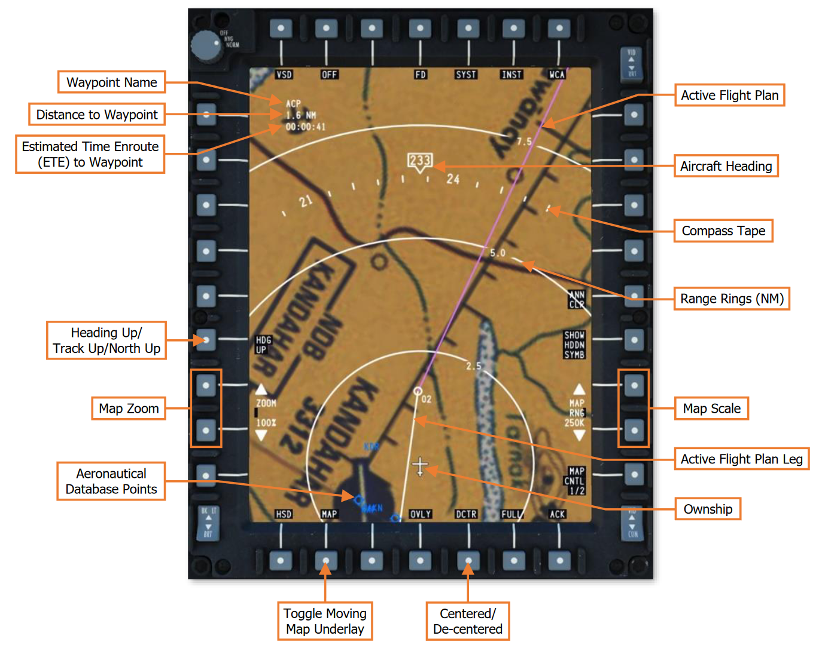
General info
- Press OVLY OSB to go to OVLY 1 page, which shows OSBs for adding information to the map.
  - FPLN shows waypoints.
  - NAV SYMB shows airports and other navigation stuff??
  - RNG RING shows range rings, labeled in NMI.
- More todo??

